HandGesture Studio: Gesture-Controlled Drawing and Media Controller
Advanced OpenCV Laboratory · Variant 9 · Southville International School and Colleges

1. Title Page
Project title | HandGesture Studio: Gesture-Controlled Drawing and Media Controller
Course / subject | Advanced OpenCV Laboratory
School | Southville International School and Colleges
Assigned variant | Variant 9
Program files | prelab/handgesture_prelab.py (Pre-Lab), lab/handgesture_lab.py (Lab)
Technologies | Python 3, OpenCV, MediaPipe Hands, NumPy
Platforms | Windows, macOS, Linux
Student name(s) | Beatrice Claire D. Oira
Section / year level | BSCpE-4
Instructor | John Anthony PEngr. John Pio Anthony A. Buena, CCpE
Date submitted | October 8, 2026

2. Objectives
The laboratory has one overall goal: turn a webcam and MediaPipe hand landmarks into a reliable, safe, multi-mode gesture interface.

The specific objectives are:
- Explain how MediaPipe Hands produces 21 landmarks per hand and how those landmarks are turned into recognised gestures.
- Preserve the Pre-Lab media controller (volume, play/pause, track swipe, mute, lock/unlock) and extend it with a drawing studio.
- Implement all four gesture types: static poses, motion gestures, distance-based gestures and multi-stage (hold or sequence) gestures.
- Design a state manager (LOCKED, MEDIA, DRAWING) so that one hand can safely control two different applications.
- Build a drawing engine (freehand, eraser, line, rectangle, circle, ten colors, brush sizes) with undo, redo, clear and save.
- Build an OpenCV interface (toolbar, dashboard, overlays) that gives clear feedback for every gesture.
- Reduce false positives with confirmation holds, cooldowns, stillness checks, smoothing and mode-aware recognition.
- Make the program run on Windows, macOS and Linux.
- Test the program systematically, document the results honestly, and reflect on thresholds, conflicts and limitations.

3. Original Program Analysis

3.1 What the original program did
The supplied handgesture_lab.py was a single Python file built around one webcam loop. Each frame is mirrored, passed to MediaPipe Hands (one hand, detection and tracking confidence 0.7), classified into a gesture, dispatched to the handler of the current mode, and drawn as a composite image. Its main parts were:
Part | Role in the original
LinuxMediaController | Media control through playerctl (play, next, previous), pactl and wpctl (volume, mute)
StateManager | Holds the mode (LOCKED, MEDIA, DRAWING), lock flag, volume, cooldown timer, swipe history, action log
HistoryManager | One stack of canvas snapshots, undo only (30 steps)
ShapeRenderer | Stores start and current point of a line, rectangle or circle and draws a live preview
Toolbar | Three always-visible rows (8 tools, 10 colors, 6 sizes) selected by hovering the index finger
Gesture helpers | Finger-extended tests, thumb heuristic, pinch test, swipe test, recognize_gesture classifier
dwell() helpers | Hold-to-confirm timers that fire once per hold
Cursor | Moving-average plus exponential smoothing of the index fingertip
Handlers and process_frame | Mode logic, rendering and the dashboard
The design had several good ideas that were kept: a pure classifier with no side effects, dwell timers that fire once per hold, a shared cooldown, a separate canvas that is blended with the camera image, and a history stack that is pushed before every change.

3.2 Weaknesses found
Reading and running the original showed problems that the modified program addresses.
# | Weakness | Effect | Resolution in the modified program
1 | Media control and camera path were Linux only (playerctl, pactl, /dev/video0) | Program unusable on Windows or macOS | MediaController with Windows, macOS and Linux backends; per-OS camera backends
2 | Undo only | Mistaken undo could not be reversed | Separate undo and redo stacks
3 | Toolbar always occupied 148 px of the canvas | Crowded screen | Slim header plus three collapsible bars
4 | Colors, tools and sizes selectable only by hovering | Slow; no shortcut | Gesture shortcuts, mouse buttons and keyboard keys
5 | The white canvas was blended into the camera view even in MEDIA mode | Washed-out media screen | Mode-specific rendering
6 | Dashboard text overlapped (action log at w-310 collided with the middle and right columns) | Hard to read | Rebuilt dashboard layout
7 | Hold actions (clear, save, play/pause) counted while the hand was moving; three-finger undo repeated on every cooldown | Accidental triggers during swipes | Stillness check, flick detection, undo hold dwell
8 | Swipe detection was horizontal only | No spare gesture axis | Four-direction flick detection
9 | Unlocking always went to MEDIA | Lost the previous mode | resume_mode remembered
10 | MediaPipe Hands object created at import | Module could not be imported or tested without the model | Created inside main()
11 | Constants MIN_BRUSH_SIZE, MAX_BRUSH_SIZE and variable swipe_cooldown_note were unused; hover flags were set in two places | Dead code, duplicated logic | Brush limits now used by the horns gesture; single toolbar.hover
12 | No way to disable a gesture that misfires | A noisy gesture could not be silenced | Hand-control switches (Section 19 and 20)

4. Pre-Lab Architecture and Implemented Gestures

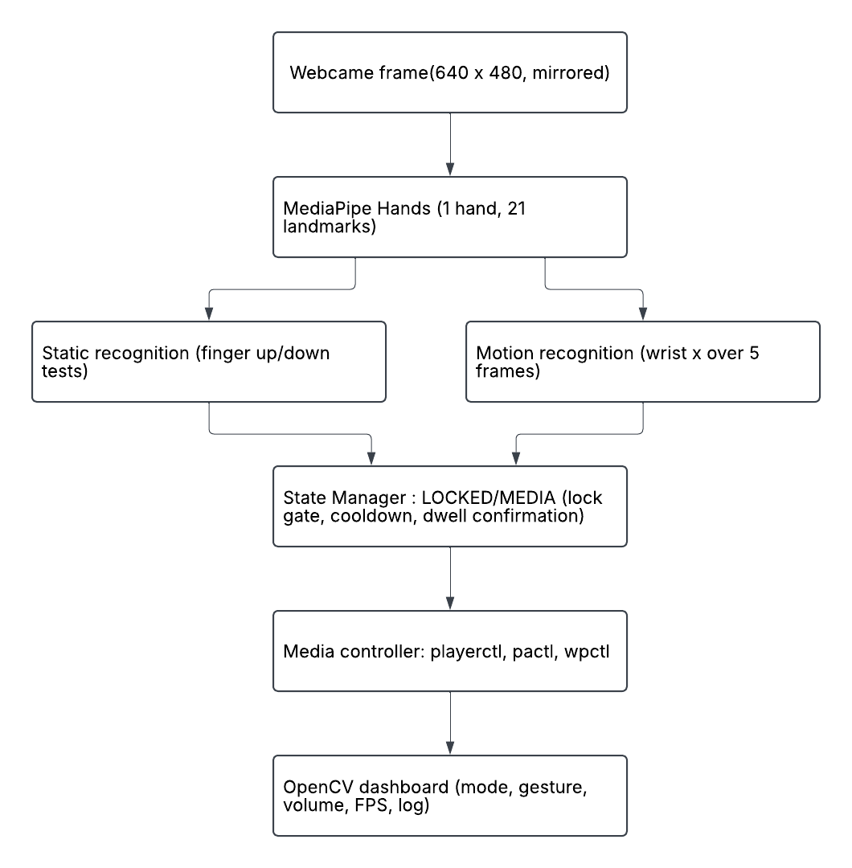
4.1 Pre-Lab pipeline

The Pre-Lab has two states. In LOCKED all gestures are ignored except the unlock gesture, which prevents accidental control when the user is simply moving their hand in front of the camera. In MEDIA the media gestures act.

4.2 Pre-Lab gestures
Gesture | Type | Action | Key parameters
Index finger up, others down, thumb moved toward or away from the index tip | Distance-based | Volume 0 to 100 percent | Distance 0.02 maps to 0 percent and 0.3 to 100 percent (normalised image units); the volume is only sent when it changes by at least 3 points
Open palm (four fingers up, thumb out), held still | Static + hold | Play / pause | Hold PALM_DWELL = 0.4 s, then cooldown
Open hand moved quickly right or left | Motion | Next / previous track | Wrist moves at least 80 px within the last 5 frames
Closed fist, released quickly | Static + timing | Mute / unmute | Fist held between 0.1 s and 0.5 s
Two fingers (index + middle), held | Static + hold | Lock / unlock | Hold CONFIRMATION_TIME = 0.5 s
Two mechanisms from the Pre-Lab are reused everywhere in the Lab:
- Dwell (hold to confirm): dwell(name, secs) is called every frame while a condition holds. It returns True once, after the condition has been seen continuously for secs, and stays False until the condition is broken.
- Cooldown: after most actions, COOLDOWN_TIME = 0.7 s must pass before the next one, so a single gesture cannot fire repeatedly.

5. Assigned Lab Variant and Requirements
Assigned variant: Variant 9 (printed in the dashboard header as "ADVANCED OPENCV LABORATORY | VARIANT 9").
Implement freehand drawing, eraser, color selection, thickness control, line, rectangle, circle, undo, clear, and save output. Tool selection must occur through gesture interaction with an OpenCV toolbar or defined screen zones.

ID | Requirement | Implementation | Status
R1 | Preserve the Pre-Lab media gestures | MEDIA mode: volume, play/pause, flick next/previous, fist tap mute, two-finger lock | Done
R2 | Freehand drawing with adjustable brush size | DRAW tool; SIZE bar (2, 5, 10, 20, 30, 50 px); horns gesture for continuous size | Done
R3 | Eraser | ERASE tool, fixed 40 px | Done
R4 | 10-color palette | COLOR bar; flick left/right to cycle | Done
R5 | Line, rectangle and circle tools | LINE, RECT, CIRCLE with live preview, committed by pinch | Done
R6 | Undo (history based) | 30-step snapshot stack; redo added as an extension | Done
R7 | Clear canvas with confirmation | Four fingers held 0.5 s with progress bar | Done
R8 | Save to a timestamped PNG | output/drawing_YYYYMMDD_HHMMSS.png | Done
R9 | Gesture-controlled toolbar with hover feedback | Index hover for 0.4 s with a progress bar on the button | Done
R10 | State management (LOCKED, MEDIA, DRAWING) | StateManager, Section 15 | Done
R11 | Dashboard (mode, gesture, tool, FPS, recent actions) | Foldable, resizable status panel | Done
R12 | Robustness (cooldown, confirmation, empty history, save failure, webcam failure) | Sections 17, 18 and 21 | Done
R13 | Documentation, test plan and results | This document | Done(Majority – aside from surprise modification).

Extensions added due to personal taste:
ID | Extension
E1 | Two clearly separated modes (media and drawing), each showing only its own controls, detections, log lines and overlays
E2 | Redo, with buttons and gestures for undo, redo, draw, save, colors, shapes and sizes
E3 | Distance-based gesture that resizes the window
E4 | Cross-platform support (Windows, macOS, Linux)
E5 | Collapsible tool, color and size bars
E6 | Hand controls that can be switched off and on individually
E7 | Status panel that is resizable and foldable

6. MediaPipe Landmark Map
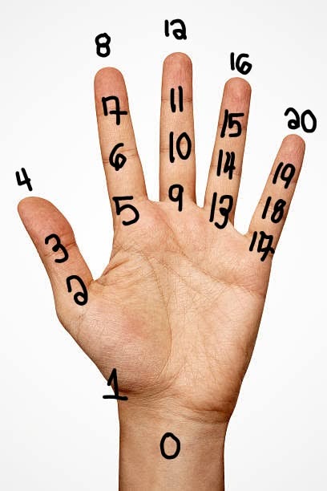
MediaPipe Hands returns 21 landmarks per hand. Each has normalised x and y (0 to 1 across the image width and height) and a relative depth z. The program uses x and y only. Because the frame is mirrored before detection, a larger x always means "further right on screen".

- Wrist = 0
- Trapezium area = 1
- Thumb = 2-4
- Index = 5-8
- Middle = 9-12
- Ring = 13-16
- Pink = 17-20

Index | Name | Used by the program | How it is used
0 | WRIST | Yes | Flick and stillness tracking (x and y over 5 frames); palm length (with 9)
1 | THUMB_CMC | No
2 | THUMB_MCP | No
3 | THUMB_IP | Yes | Thumb-extended test (compared with the tip)
4 | THUMB_TIP | Yes | Pinch, thumb-index volume distance, thumb extended, shaka span
5 | INDEX_FINGER_MCP | No
6 | INDEX_FINGER_PIP | Yes | Index extended if tip is above this joint
7 | INDEX_FINGER_DIP | No
8 | INDEX_FINGER_TIP | Yes | Drawing cursor, toolbar hover, pinch, volume, horns span
9 | MIDDLE_FINGER_MCP | Yes | Palm length (distance 0 to 9) used to normalise spans
10 | MIDDLE_FINGER_PIP | Yes | Middle extended test
11 | MIDDLE_FINGER_DIP | No
12 | MIDDLE_FINGER_TIP | Yes | Middle extended test
13 | RING_FINGER_MCP | No
14 | RING_FINGER_PIP | Yes | Ring extended test
15 | RING_FINGER_DIP | No
16 | RING_FINGER_TIP | Yes | Ring extended test
17 | PINKY_MCP | Yes | Reference point of the thumb-extended test
18 | PINKY_PIP | Yes | Pinky extended test
19 | PINKY_DIP | No
20 | PINKY_TIP | Yes | Pinky extended test, horns span, shaka span
Thirteen of the 21 landmarks are used: 0, 3, 4, 6, 8, 9, 10, 12, 14, 16, 17, 18, 20.

Landmark pairs used for "finger extended" (image y grows downwards, so "above" means a smaller y):
Finger | Tip | PIP joint | Extended when
Index | 8 | 6 | tip.y < pip.y
Middle | 12 | 10 | tip.y < pip.y
Ring | 16 | 14 | tip.y < pip.y
Pinky | 20 | 18 | tip.y < pip.y
This test assumes the hand is roughly upright, which is the natural position when facing the camera.

Landmarks per gesture:
Gesture | Landmarks
Volume | 4 and 8 (distance in normalised units)
Pinch | 4 and 8 (distance below 0.05)
Drawing cursor and toolbar hover | 8 (pixel position, smoothed)
Flick, stillness | 0 (wrist, last 5 frames)
Horns brush size | 8 and 20, divided by distance 0 to 9
Shaka window size | 4 and 20, divided by distance 0 to 9; thumb out from 3, 4, 17
Open palm vs four fingers | Thumb test on 3, 4, 17

7. System Architecture and State Diagram

7.1 System architecture
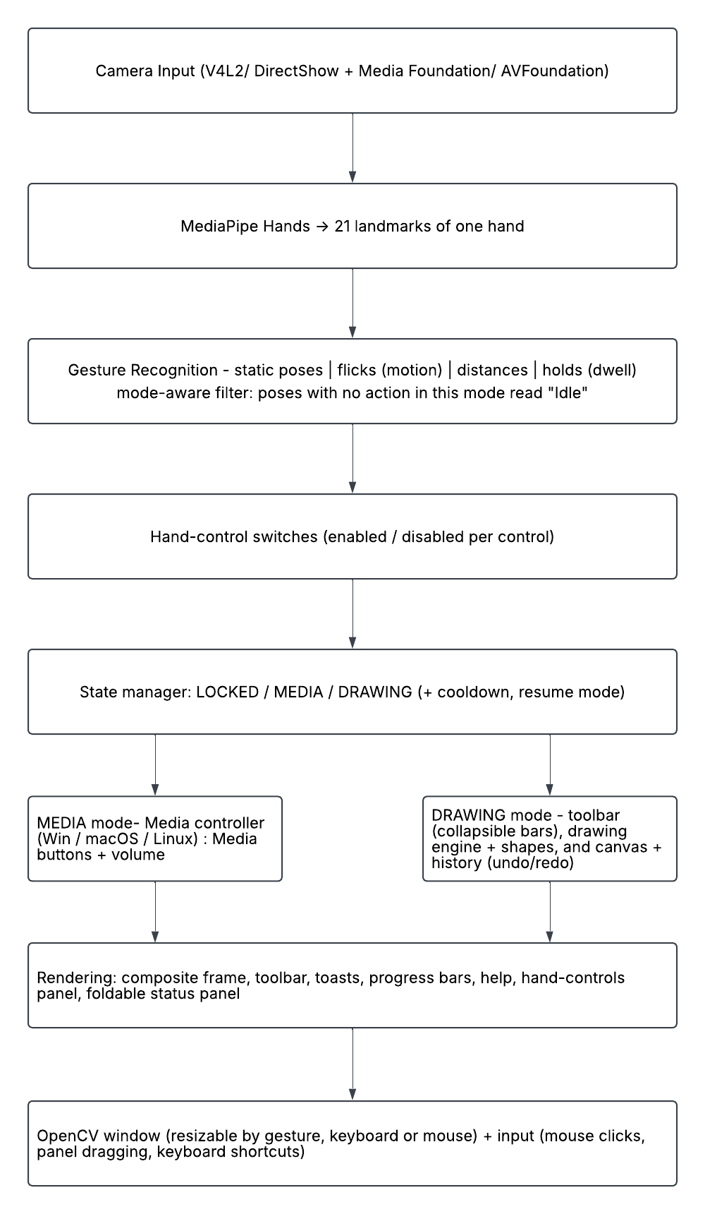

7.2 Main components
Component | Responsibility
MediaController | Play/pause, next, previous, volume, mute for Windows, macOS and Linux; every backend optional
StateManager | Mode, lock flag, resume mode, volume estimate, cooldown timer, flick history, action log with kinds (sys, media, draw), toast
HistoryManager | Undo and redo stacks of canvas snapshots (30 steps each)
ShapeRenderer | Start point, current point and drawing of line, rectangle, circle and their live preview
Toolbar | Header, three collapsible bars, media row; hit testing and drawing
WindowManager | Window scale, screen-size cap, fullscreen, closed-window detection
DashPanel | Status panel height, folded or open, edge dragging
ControlsPanel | Overlay for switching hand controls on and off
Cursor, Smoother | Fingertip smoothing; smoothing of brush size and window scale
dwell() helpers | Hold-to-confirm timers and progress

7.3 State diagram

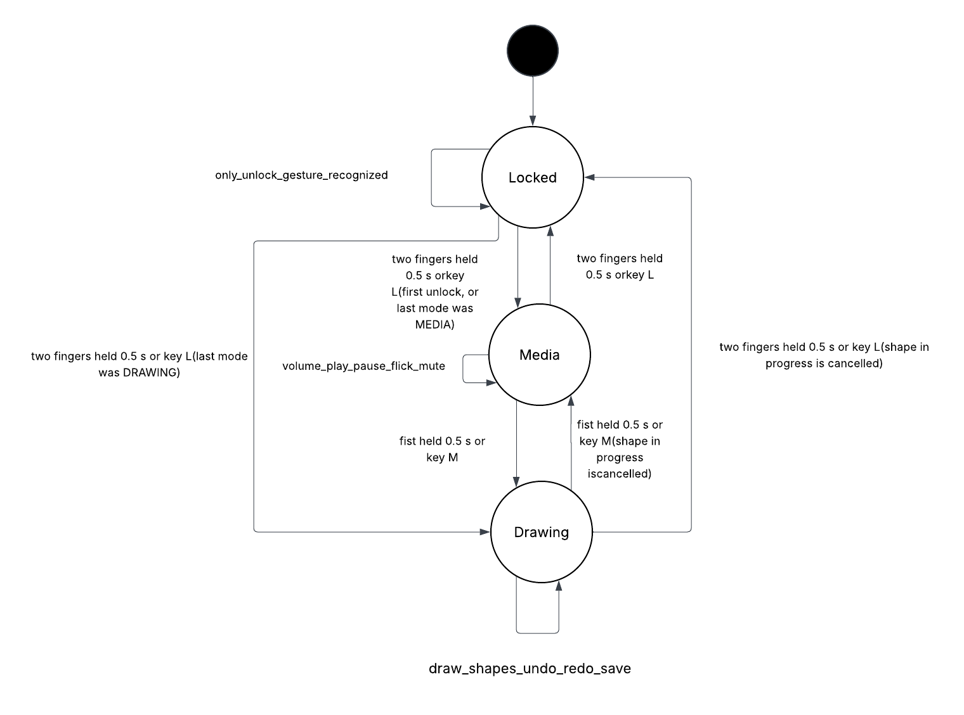

From | To | Trigger | Conditions
LOCKED | MEDIA or DRAWING | Two fingers held 0.5 s, or key l | Returns to the mode that was active before locking; MEDIA the first time
MEDIA | LOCKED | Two fingers held 0.5 s, or key l | The lock control may be switched off, but unlocking by gesture always works
DRAWING | LOCKED | Two fingers held 0.5 s, or key l | Any shape in progress is cancelled
MEDIA | DRAWING | Fist held 0.5 s, or key m | Unlocked; not while the hand-controls panel is open; the mode-switch control must be on
DRAWING | MEDIA | Fist held 0.5 s, or key m | Same as above; a shape in progress is cancelled

8. Program Flowchart

8.1 Main loop

https://lucid.app/lucidchart/16fb152e-45b8-4864-ad94-8a7f1e2cf9e5/edit?viewport_loc=-590%2C1717%2C5283%2C2874%2CBjzBx68PweH4&invitationId=inv_6d538946-610c-4a0b-8542-4cea42a9afe9

8.2 One frame (process_frame)
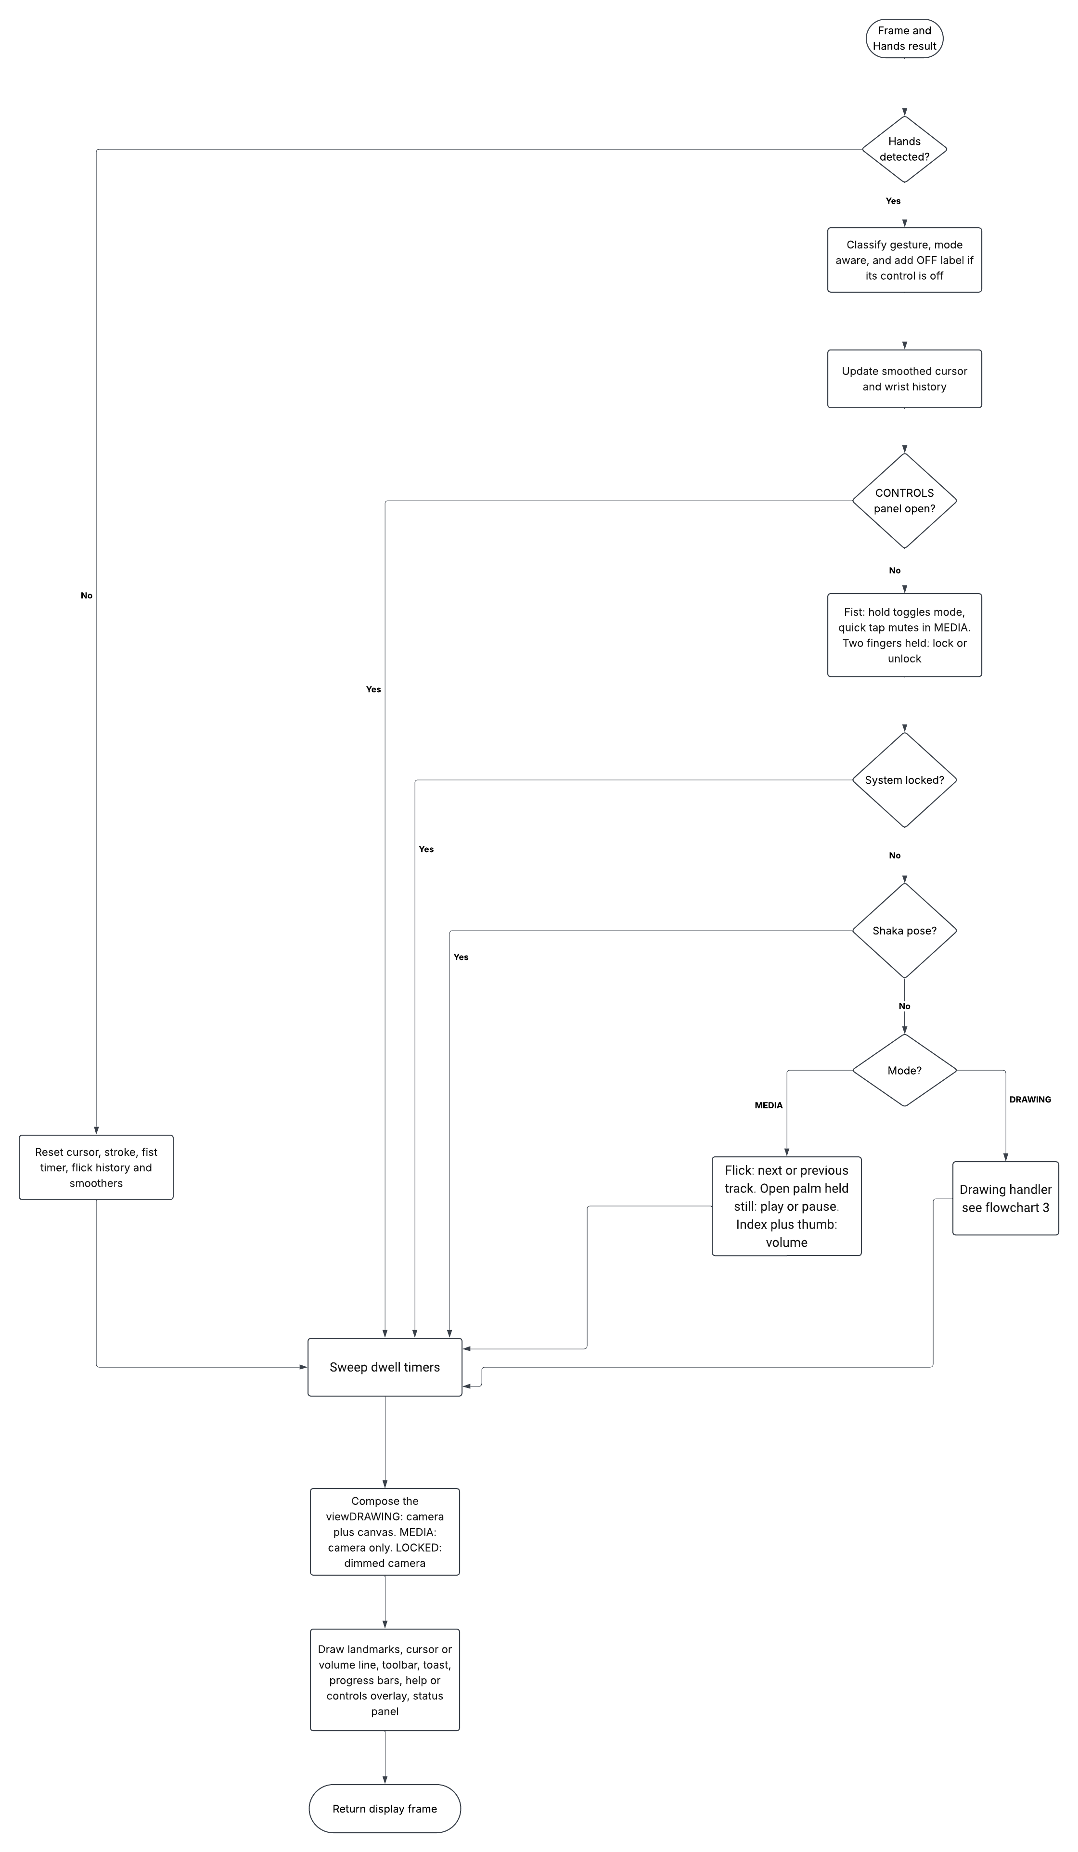

8.3 Drawing branch (index finger)
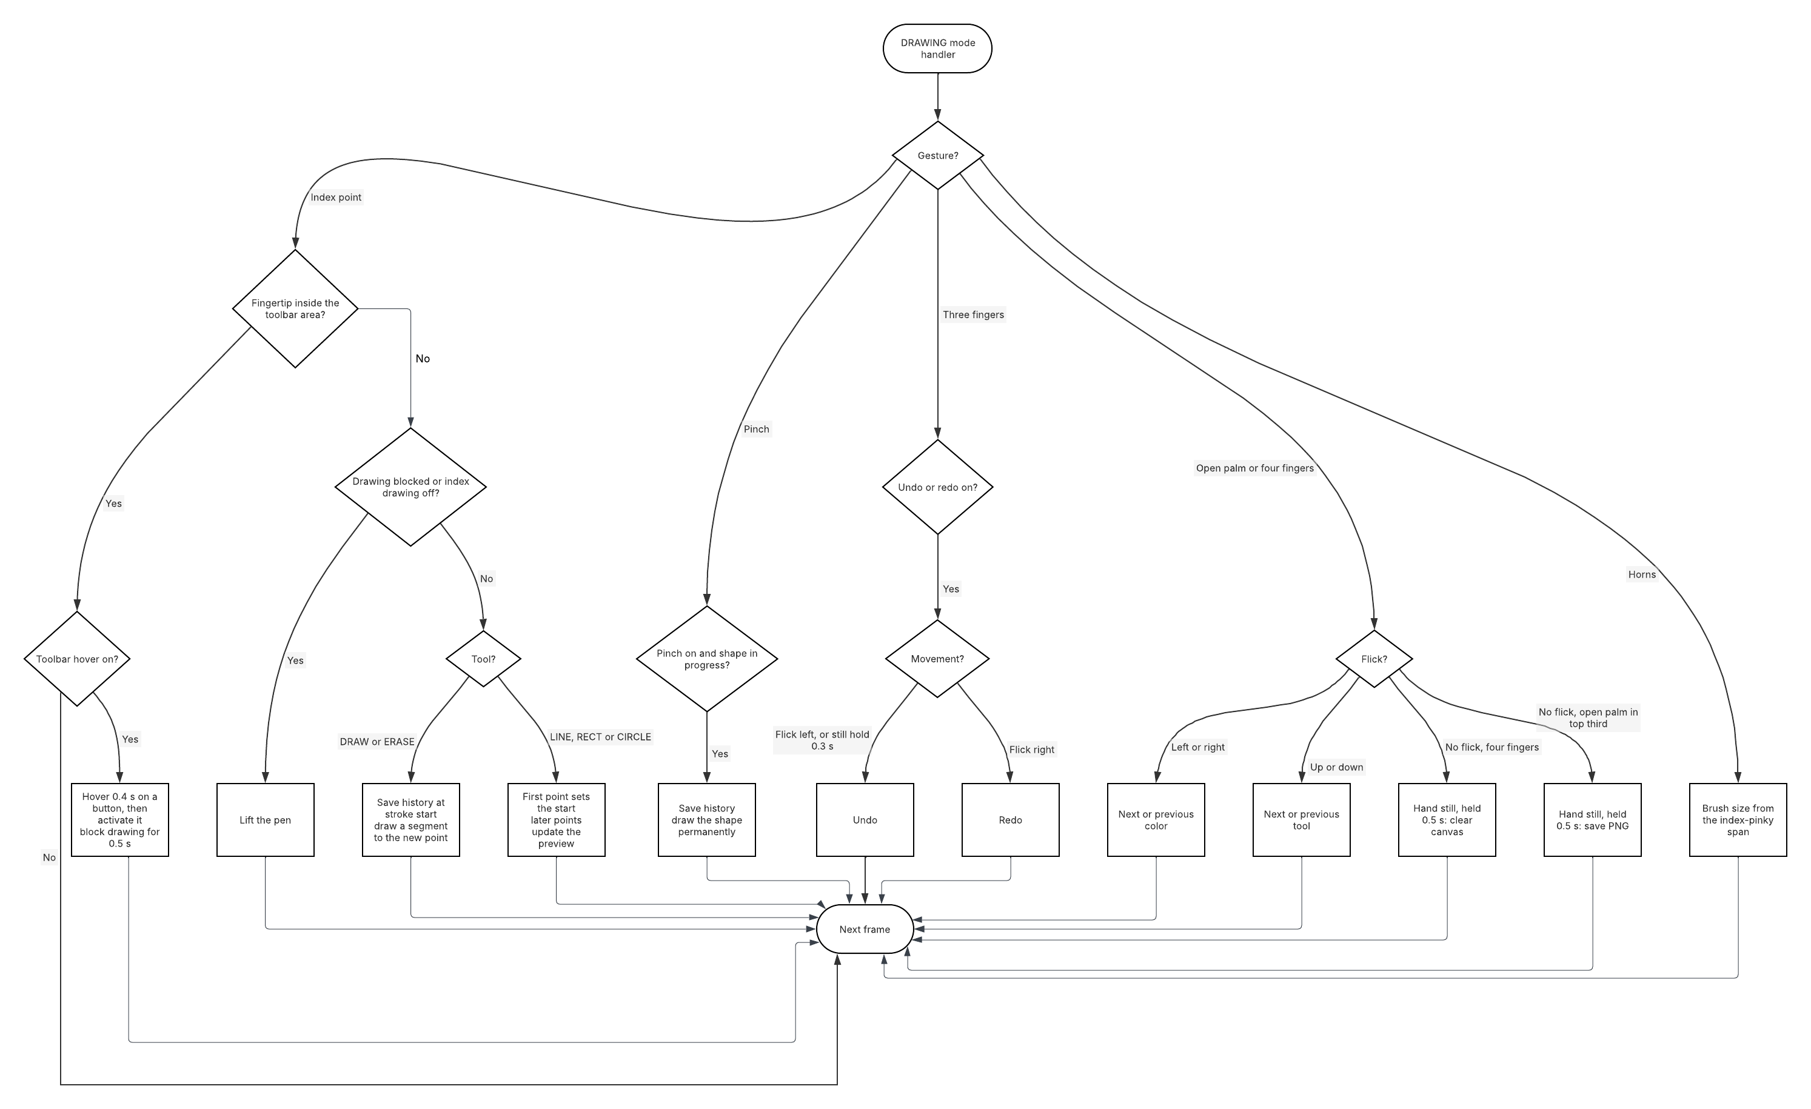
Link -
https://lucid.app/lucidchart/16fb152e-45b8-4864-ad94-8a7f1e2cf9e5/edit?viewport_loc=-20%2C242%2C3960%2C2154%2C6vDB6~UiyQwk&invitationId=inv_6d538946-610c-4a0b-8542-4cea42a9afe9

9. Gesture Recognition Algorithms and Pseudocode

9.1 Finger states and static poses
function fingers(lm):
return (lm[8].y < lm[6].y, # index extended
lm[12].y < lm[10].y, # middle extended
lm[16].y < lm[14].y, # ring extended
lm[20].y < lm[18].y) # pinky extended
function thumb_extended(lm):
return |lm[4].x - lm[17].x| > |lm[3].x - lm[17].x|
function classify(lm, mode):
f = fingers(lm)
if f == (0,0,0,0): return "fist"
if f == (0,0,0,1) and thumb_extended: return "shaka"
if f == (1,0,0,1): return "horns"
if f == (1,1,0,0): return "two_finger"
if f == (1,1,1,0): return "three_finger"
if f == (1,1,1,1) and not thumb_extended: return "four_finger"
if f == (1,1,1,1) and thumb_extended: return "open_palm"
if mode == DRAWING and distance(lm[4], lm[8]) < 0.05: return "pinch"
if f == (1,0,0,0): return "index_point"
return "none"
function recognize(lm, mode):
g = classify(lm, mode)
if g not in ALLOWED[mode]: return "none" # shown as Idle
return g
The order matters: the fist is tested first, then the most specific poses, and the pinch is tested before the index point so that touching the thumb to the index finger is never mistaken for pointing while drawing. The ALLOWED table says which gestures do anything in each mode: LOCKED allows only two_finger; MEDIA allows fist, shaka, two_finger, four_finger, open_palm, index_point; DRAWING allows all of them plus three_finger, pinch and horns.

9.2 Dwell (hold to confirm)
function dwell(name, secs): # call every frame while the condition holds
seen.add(name)
if name in fired: return False
start = starts.setdefault(name, now)
if now - start >= secs:
fired.add(name); return True
return False
function sweep(): # call once per frame, after all handlers
for name in starts: if name not in seen: forget(name)
fired = fired intersect seen
seen.clear()
A hold therefore fires exactly once; releasing or changing pose forgets it, so the user must release and repeat to fire again.

9.3 Flick (motion) detection and stillness
history = last 5 wrist positions (x, y) in pixels
function detect_flick(history):
if len(history) < 5: return None
dx = history[-1].x - history[0].x; dy = history[-1].y - history[0].y
if |dx| >= 80 and |dx| > 1.5*|dy|: return "right" if dx > 0 else "left"
if |dy| >= 60 and |dy| > 1.5*|dx|: return "down" if dy > 0 else "up"
return None
function hand_still(history):
if len(history) < 5: return False
return (max x - min x) < 35 and (max y - min y) < 35
After a flick fires, the history is cleared. That prevents double firing and also makes the hand count as "not still" for the next five frames. Hold-type actions (clear, save, play/pause, undo hold) require hand_still, so a flick can never also trigger them.

9.4 Distance-based mappings
# volume (Pre-Lab): thumb-index distance in normalised image units
volume = round(clamp((dist(4,8) - 0.02) / (0.30 - 0.02), 0, 1) * 100)
send only if |volume - last| >= 3 and 0.12 s have passed
# spans normalised by palm length so they do not depend on camera distance
palm = pixel_distance(lm[0], lm[9])
# horns -> brush size (2..50 px)
t = clamp((pixel_distance(lm[8], lm[20]) / palm - 0.5) / (1.4 - 0.5), 0, 1)
size = round(smooth(2 + t * (50 - 2)))
# shaka -> window scale (0.5 .. max_scale)
t = clamp((pixel_distance(lm[4], lm[20]) / palm - 0.9) / (2.0 - 0.9), 0, 1)
scale = smooth(0.5 + t * (max_scale - 0.5)) # max_scale from screen size, at most 3.0

9.5 Cursor smoothing
history = last 5 fingertip positions
raw = average(history)
smooth = 0.65 * raw + 0.35 * previous_smooth # exponential moving average
The moving average removes landmark jitter and the exponential term adds a little inertia. The cost is a small lag, which is why the 0.5 s drawing guard is also needed after toolbar presses (Section 24).

9.6 Undo and redo
push(canvas): # called BEFORE a change
redo_stack.clear()
if undo_stack top equals canvas: return
undo_stack.append(copy(canvas)); keep at most 30
undo(current): if undo_stack empty: return None
redo_stack.append(copy(current)); return undo_stack.pop()
redo(current): if redo_stack empty: return None
undo_stack.append(copy(current)); return redo_stack.pop()
Starting a new stroke after an undo clears the redo stack, which matches the behaviour of normal editors.

9.7 Hand-control switches
enabled = {control_id: True for each control}
before running an action: if not enabled[control_id]: skip it
exceptions: unlocking by gesture always works; keys and mouse are never switched off
while the CONTROLS panel is open: skip all gesture actions

10. Static, Motion, Distance-Based and Multi-Stage Gestures
The program uses four families of gestures. Each family has its own typical failure, so each has its own protection.

10.1 Static gestures (one frame is enough)
A static gesture is decided from the finger states of a single frame. It is fast and simple, but it is the most prone to false positives because brief, in-between hand shapes also match.
Gesture | Finger pattern (index, middle, ring, pinky) | Notes
Closed fist | 0 0 0 0 | Thumb ignored
Index point | 1 0 0 0 | Drawing cursor; in MEDIA mode the pose that enables the volume distance
Two fingers | 1 1 0 0 | Lock and unlock
Three fingers | 1 1 1 0 | Undo and redo
Four fingers | 1 1 1 1, thumb tucked | Clear; flick for color or tool
Open palm | 1 1 1 1, thumb out | Play/pause, save; flick for track, color or tool
Horns | 1 0 0 1 | Brush size
Shaka | 0 0 0 1, thumb out | Window size
Pinch | Thumb tip within 0.05 of the index tip (DRAWING only) | Commits a shape
Protection: a pure classifier checked in a fixed order; a mode filter so that poses with no function in the current mode read as Idle; and in most cases a confirmation hold (below).

10.2 Motion gestures (change over time)
A motion gesture compares the wrist position over the last 5 frames (about 0.15 to 0.2 s at 30 FPS).
Gesture | Direction | MEDIA | DRAWING
Open hand flick | Right / left | Next / previous track | Next / previous color
Open hand flick | Down / up | Not used | Next / previous tool
Three-finger flick | Left / right | Not used | Undo / redo
A flick must move at least 80 px horizontally or 60 px vertically, and the main direction must be at least 1.5 times larger than the other axis, so diagonal wobbling is ignored. The same pose can be a static gesture and a motion gesture, for example three fingers: held still it undoes, flicked it undoes or redoes depending on the direction.
Protection: cooldown after every flick, clearing of the movement history after a flick, and the requirement that every hold-type action sees a still hand.

10.3 Distance-based gestures (a continuous value)
Gesture | Distance measured | Result
Thumb-index (MEDIA, index point) | Landmarks 4 and 8, normalised image units 0.02 to 0.3 | Volume 0 to 100 percent
Horns spread (DRAWING) | Landmarks 8 and 20 divided by palm length, 0.5 to 1.4 | Brush size 2 to 50 px
Shaka spread (any mode) | Landmarks 4 and 20 divided by palm length, 0.9 to 2.0 | Window scale 0.5 to the screen limit
Pinch (DRAWING) | Landmarks 4 and 8 below 0.05 | Commit shape (a threshold, not a continuous value)
Circle tool | Distance from start point to fingertip | Circle radius
The horns and shaka spans are divided by the palm length (wrist to middle-finger base) so that moving the hand closer to or further from the camera does not change the result. The values are smoothed with an exponential average so that the brush size and window size do not flicker.
Protection: clamping to a range, smoothing, a minimum change of 3 points for volume, and at most one volume command every 0.12 s.

10.4 Multi-stage gestures (a sequence or a hold)
Gesture | Stages | Why
Lock / unlock | Two fingers held 0.5 s, progress bar, then toggle | Prevents accidental locking
Mode switch | Fist held 0.5 s, progress bar, then toggle | Separates it from the mute tap
Mute | Fist closed and released between 0.1 and 0.5 s | The same pose means mute (short) or switch mode (long)
Clear | Four fingers, hand still, held 0.5 s, progress bar | Destructive action needs confirmation
Save | Open palm in the top third of the image, hand still, held 0.5 s | Position plus hold
Toolbar button | Index fingertip over a button for 0.4 s, progress bar, activate, then 0.5 s drawing pause | Hover feedback and no stray stroke afterwards
Shape | Choose tool, index finger sets the start, move to see the preview, pinch to commit | Three stages with a live preview
Undo hold | Three fingers, hand still, held 0.3 s | Lets a slow user undo without a flick
For all hold-type stages the dwell timer is forgotten as soon as the pose changes or the hand moves, so a hold must be unbroken.

11. OpenCV Interface and Dashboard Explanation

11.1 Layout in DRAWING mode

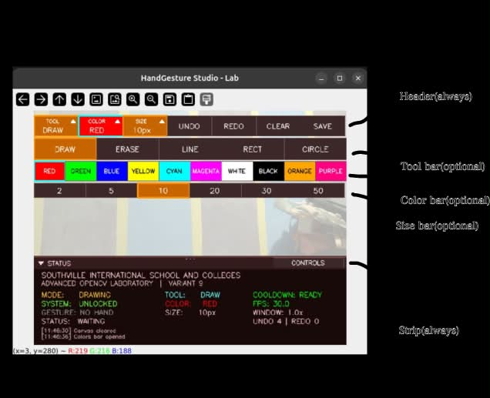

11.2 Elements and the OpenCV calls behind them
Element | Behaviour | OpenCV functions
Camera composite | DRAWING: 35 percent camera plus 65 percent canvas; MEDIA: full camera; LOCKED: dimmed camera | cv2.flip, cv2.addWeighted
Header and bars | Buttons with the current tool, color swatch and size; arrows show open or closed; bars start closed | cv2.rectangle, cv2.fillPoly, cv2.getTextSize, cv2.putText
Hover feedback | Green border and a growing bar along the bottom of the button while the finger dwells | cv2.rectangle
Fingertip cursor | Ring and dot colored by gesture (DRAWING only) | cv2.circle
Volume line (MEDIA) | Line between thumb and index tip while the volume gesture is active | cv2.line, cv2.circle
Landmarks | Hand skeleton from MediaPipe | mp_draw.draw_landmarks
Brush preview | Filled circle of the current size and color while the horns gesture is active | cv2.circle
Toast message | Short message in an outlined font (only messages that belong to the current mode) | cv2.putText twice (outline and fill)
Progress bars | Fill while holding for clear, save, lock, mode switch or undo | cv2.rectangle
Help overlay (h) | Dark overlay with the controls of the current mode; line spacing adapts to the panel height | cv2.addWeighted
Hand-controls panel (g or CONTROLS) | Two columns of check boxes, ALL ON and CLOSE | cv2.rectangle, cv2.line
Status panel | Strip plus body; foldable and resizable | cv2.rectangle, cv2.circle, cv2.putText
Window | Resizable window with mouse callback | cv2.namedWindow, cv2.resizeWindow, cv2.setMouseCallback, cv2.imshow, cv2.waitKey
OpenCV uses BGR color order, so a color written (255, 50, 50) is blue, not red. The lock indicator in the status panel uses this value.

11.3 MEDIA mode interface
The full camera image is shown with a single row of media buttons (PREV, PLAY/PAUSE, NEXT, MUTE, VOL-, VOL+) that can be clicked with the mouse. A volume bar and number show the current volume. While the volume gesture is active a line joins the thumb and index tips. The status panel shows the volume instead of tool, color and size, and the action log only shows media and system events. Nothing drawing-related (canvas, toolbar, cursor, tool, color, size, undo counts) appears in MEDIA mode, and nothing media-related appears in DRAWING mode.

11.4 Status panel
- Fold or unfold: click the arrow at the left of the strip, press v, or drag the top edge to the bottom or back up. When folded the strip shows one line: mode, gesture and FPS.
- Resize: drag the top edge (a 6 px grab zone, marked by three dots). < and > change the height by 20 px. The height is limited to 96 px at the smallest and 320 px (or the frame height minus 150) at the largest.
- Adaptive content: rows are drawn from top to bottom (school header, status rows, action log) and a row is only drawn if it fits completely, so shrinking the panel hides the log first and then the lower rows instead of cutting text in half.
- CONTROLS button: always visible on the strip, shows how many controls are off, and opens the hand-controls panel.
- Mode-specific content: in DRAWING the middle column shows tool, color and size and the right column shows cooldown, FPS, window scale and undo/redo counts; in MEDIA the middle column shows volume and the right column shows cooldown, FPS and window scale; in LOCKED only FPS is shown.

12. Modified Code Sections and Technical Explanation
The sections below describe the main changes from the original program. Each one gives the problem, the change and the reason, with the key lines.

12.1 Undo and redo (HistoryManager)
Problem: one stack, undo only. Change: two stacks. push() is called before every change and clears the redo stack; undo(current) stores the present canvas on the redo stack; redo(current) stores it on the undo stack. Both stacks keep at most 30 snapshots (about 0.9 MB each at 640 x 480).
def push(self, canvas):
self.redo_stack.clear()
if self.undo_stack and np.array_equal(self.undo_stack[-1], canvas):
return
self.undo_stack.append(canvas.copy())
def undo(self, current):
if not self.undo_stack:
return None
self.redo_stack.append(current.copy())
return self.undo_stack.pop()

12.2 Flick detection and the stillness check
Problem: horizontal swipe only; hold actions fired during movement. Change: the wrist history now stores (x, y), flicks have four directions with an axis-dominance rule, and hand_still() is required by every hold-type action.
def detect_flick(hist):
if len(hist) < hist.maxlen:
return None
dx = hist[-1][0] - hist[0][0]
dy = hist[-1][1] - hist[0][1]
if abs(dx) >= SWIPE_THRESHOLD and abs(dx) > 1.5 * abs(dy):
return "right" if dx > 0 else "left"
if abs(dy) >= SWIPE_THRESHOLD_V and abs(dy) > 1.5 * abs(dx):
return "down" if dy > 0 else "up"
return None

12.3 Mode-aware gesture recognition
Problem: every pose was reported in every mode, so poses with no function looked like detections. Change: the original classifier became _classify_gesture, and a thin wrapper keeps only gestures that act in the current mode.
MODE_GESTURES = {
MODE_LOCKED: {"two_finger"},
MODE_MEDIA: {"fist", "shaka", "two_finger", "four_finger", "open_palm", "index_point"},
MODE_DRAWING: {"fist", "shaka", "two_finger", "three_finger", "four_finger",
"open_palm", "pinch", "index_point", "horns"},
}
def recognize_gesture(lm, mode):
gtype, desc = _classify_gesture(lm, mode)
if gtype != "none" and gtype not in MODE_GESTURES.get(mode, ()):
return "none", "Idle"
return gtype, desc

12.4 Cross-platform media control (MediaController)
Problem: LinuxMediaController only. Change: one class with a backend per OS, chosen at run time. Every backend is optional; a missing one makes the action report "failed" instead of crashing.
Action | Windows | macOS | Linux
Play/pause, next, previous | Virtual-key events through ctypes (keybd_event, keys 0xB3, 0xB0, 0xB1) | System media key through pyobjc, else nowplaying-cli, else AppleScript for Spotify or Music | playerctl (preferred player first, then any), else xdotool
Volume | pycaw exact volume; otherwise volume keys (2 percent each) | osascript | pactl, wpctl, then amixer
Mute | pycaw toggle or mute key | osascript | pactl, wpctl, then amixer
def _transport(self, name):
if IS_WINDOWS:
return self._win_key(name)
if IS_MAC:
return self._mac_transport(name)
return self._linux_transport(name)
The volume command is throttled to one per 0.12 s so a slow backend (AppleScript) does not slow the video.

12.5 Camera start-up
Problem: /dev/video0 through V4L2 only. Change: the list of backends depends on the OS (DirectShow then Media Foundation on Windows, AVFoundation on macOS, V4L2 on Linux, always with a generic fallback), the camera index can be set with --camera, and the property order from the known-working Brio 100 setup is kept: size, then MJPG, then FPS.
cap.set(cv2.CAP_PROP_FRAME_WIDTH, 640)
cap.set(cv2.CAP_PROP_FRAME_HEIGHT, 480)
if not IS_MAC:
cap.set(cv2.CAP_PROP_FOURCC, cv2.VideoWriter_fourcc(*"MJPG"))
cap.set(cv2.CAP_PROP_FPS, 30)

12.6 Collapsible toolbar
Problem: three bars always visible (148 px). Change: Toolbar.rows() returns only the rows that are on screen. The header is always present; each bar is added only when its flag in self.open is true. Hit testing, drawing and the "is the fingertip in the toolbar" test all use the same list, so they can never disagree.
rows = [("header", y, y + self.header_h, HEADER_BUTTONS)]
y += self.header_h
for key, height, items in bars:
if self.open[key]:
y += self.gap
rows.append((key, y, y + height, items))
y += height
After a finger press on a button the program blocks drawing for 0.5 s (draw_block_until), because the bars may have moved under the fingertip.

12.7 Gesture shortcuts in DRAWING mode
Problem: colors, tools and sizes could only be chosen by hovering. Change: open-hand flicks cycle colors (horizontal) and tools (vertical); the horns gesture sets the brush size; three fingers undo or redo. All of them check their switch with enabled().
elif gesture_type in ("open_palm", "four_finger"):
horizontal = flick in ("left", "right")
if flick and ready and enabled("color_flick" if horizontal else "tool_flick"):
state.swipe_history.clear()
if horizontal:
cycle_color(1 if flick == "right" else -1)
else:
cycle_tool(1 if flick == "down" else -1)
state.last_action_time = time.time()
elif gesture_type == "four_finger":
if enabled("clear") and still and ready and dwell("clear", CONFIRMATION_TIME):
_do_clear()

12.8 Window resize gesture and WindowManager
Change: the shaka span sets a target scale; the target is smoothed and applied with cv2.resizeWindow, throttled to one call per 0.05 s. The maximum scale is the smaller of 3.0 and what fits the screen (95 percent of its width, 88 percent of its height), where the screen size is read through ctypes on Windows or the optional screeninfo package elsewhere (1920 x 1080 is assumed if it cannot be read).
ratio = px_dist(lm[4], lm[20], w, h) / palm_size(lm, w, h)
t = clamp((ratio - RESIZE_RATIO_MIN) / (RESIZE_RATIO_MAX - RESIZE_RATIO_MIN), 0.0, 1.0)
target = WINDOW_SCALE_MIN + t * (window.max_scale - WINDOW_SCALE_MIN)
window.set_scale(scale_smoother.update(target))

12.9 Hand-control switches
Change: a registry of 16 controls (CONTROLS) and a dictionary enabled_controls. Each handler asks enabled(id) before acting. Gestures that map to one control show "(OFF)" in the status panel. While the CONTROLS panel is open, all gesture actions are paused so nothing is drawn or switched by accident. Unlocking by gesture ignores the switch so the user can never be locked out.

12.10 Status panel, mouse and keyboard
Change: DashPanel stores the height and folded state; handle_mouse() turns events from the OpenCV mouse callback into actions (grab the edge, fold, open CONTROLS, press toolbar buttons); handle_key() adds shortcuts for everything.
def drag_to(self, y, frame_h):
new_h = frame_h - y
if new_h <= DASH_STRIP_H + 14:
self.open = False
else:
self.open = True
self.height = int(clamp(new_h, DASH_MIN_H, self.max_height(frame_h)))

12.11 Smaller changes
Change | Reason
Action log entries carry a kind (sys, media, draw); toasts too | Each mode shows only its own messages
resume_mode | Unlock returns to the previous mode
MediaPipe Hands created in main(); clear error message if the classic solutions API is missing | Importable and testable; helpful error
Output folder next to the script | Works from any working directory
Closed-window detection (WND_PROP_VISIBLE, only after the window has been seen) | Closing the window with its X button ends the program
Initial system volume read when possible | The volume bar starts at the real value

13. Test Plan and Test Results

13.1 How the program was tested
Testing has two layers, and this section is honest about which results exist.
- Simulated verification (done). The program's own functions were run with synthetic hand landmarks (hand shapes built from coordinates), a controllable clock, and injected mouse and keyboard events. This checks the logic: classification, timing, state changes, undo and redo, toolbar hit testing, panel behaviour and hand-control switches. It does not prove that the thresholds feel right with a real hand, camera and lighting.
- Live webcam testing. The table in 21.3 lists the tests to run with a real hand. The Actual Result and Pass/Fail cells are intentionally empty. Replace them with what you observe.

13.2 Simulated verification results
ID | Feature | Initial state | Gesture / input | Expected result | Actual result | Pass / Fail
S01 | Static pose classification | Any mode | Synthetic landmarks for 8 poses | fist, index point, two, three, four fingers, open palm, horns, shaka recognised | All 8 recognised correctly | Pass
S02 | Undo / redo stacks | Empty history | push, undo, redo, redo | Undo returns the earlier canvas, redo the later one, a second redo returns nothing | As expected; empty redo returned None | Pass
S03 | Freehand stroke with three-finger undo and redo | DRAWING, DRAW tool | One stroke; three fingers flick left; flick right | Ink appears, disappears, reappears | Ink present, then absent, then present | Pass
S04 | Color flick | DRAWING, color RED | Open hand flick right | Color changes to the next one | RED to GREEN | Pass
S05 | Tool flick | DRAWING, tool DRAW | Open hand flick down | Next tool | DRAW to ERASE | Pass
S06 | Brush size by horns | DRAWING | Horns with narrow, then wide gap | Larger gap gives larger size, clamped at 50 | 29 px at the narrow gap, 50 px (limit) when wider | Pass
S07 | Window size by shaka | Any mode, 640 x 480 frame | Shaka with narrow, then wide thumb-pinky span | Scale grows with the span, capped | 1.0 at the narrow span, 1.98 at the wide span (cap for an assumed 1920 x 1080 screen) | Pass
S08 | Toolbar hit testing, bars closed | DRAWING | Points on the header and below it | TOOLS, SIZES and SAVE at the left, middle-left and right edge; nothing below | TOOLS at x=10, SIZES at x=200, SAVE at x=639; no zone at y=80 | Pass
S09 | Toolbar hit testing, all bars open | DRAWING, all three bars open | Points at x=10 and y = 20, 65, 110, 150 | Header, tool, color and size rows in order | TOOLS, DRAW, RED, size 2 | Pass
S10 | Open a bar by finger hover | DRAWING, bars closed | Index over COLORS for 0.4 s | Color bar opens | Color bar opened | Pass
S11 | Drawing guard after a button press | Right after S10 | Move into the canvas | No ink for 0.5 s, then drawing resumes | No ink during the guard, ink afterwards | Pass
S12 | Keys 1, 2, 3 | DRAWING | Press 1, then 2 and 3 | Each key toggles its bar | Toggled as expected | Pass
S13 | Status panel fold | Panel open | Click the arrow twice | Folds, then unfolds | Folded, then unfolded | Pass
S14 | Status panel drag and keys | Panel open | Drag edge up; drag to the bottom; drag up from folded; keys v, <, > | Taller; folded; opens; height limited to 96 to 320 px | As expected | Pass
S15 | Hand-control switches in DRAWING | Controls on | Switch off undo/redo, color flick, brush size, index drawing, clear; repeat the gestures; switch on again | Nothing happens when off; works again when on | Each switched-off gesture did nothing; each worked after switching on | Pass
S16 | Lock and mode switches | Lock off, then mode-toggle off | Two fingers while locked; fist hold while unlocked; key l | Unlock still works; fist does not switch; key locks | Unlocked by gesture; mode unchanged; key locked | Pass
S17 | Media gating | MEDIA | With play/pause, track flick and volume off, then on: open palm hold, flick, thumb-index | No backend call when off; calls when on | No calls when off; play/pause, next track and volume calls when on | Pass
S18 | Gestures pause while CONTROLS is open | Panel open | Open hand flick right | Color does not change | Color unchanged | Pass
S19 | Mode filtering | MEDIA and LOCKED | Three fingers and horns in MEDIA; open palm and two fingers in LOCKED | Idle, Idle, Idle, two fingers detected | As expected | Pass
S20 | Rendering | All modes | Render each screen at several panel heights | No overlapping text; rows hidden cleanly when short; help fits | Passed after the fixes in 21.4 | Pass

13.3 Live webcam test plan
Run the program on your own machine. For each test, perform the input, write what happened in Actual result, and mark Pass or Fail. Add the cause and the fix for every failure.
ID | Feature | Initial state | Gesture / input | Expected result | Actual result | Pass / Fail
H01 | Volume (Pre-Lab) | MEDIA, music playing | Index finger up, move thumb toward and away from the index tip | Volume follows the distance, bar and number update | https://drive.google.com/file/d/1a3i8xYn6kDb0Ne9gwp0S_EuKNMpd02Tl/view?usp=sharing | [Pass
H02 | Play / pause (Pre-Lab) | MEDIA | Open palm held still 0.4 s | Playback toggles once | https://drive.google.com/file/d/1obJbqIe95GX9RIz0w8yQu-JcV9yrjVI6/view?usp=drive_link | Pass
H03 | Next / previous (Pre-Lab) | MEDIA | Open hand flick right, then left | Next track, then previous track; one action per flick | https://drive.google.com/file/d/1x3bsqszMLKYFpC126vHdLloUJtTTkEbZ/view?usp=drive_link | Pass
H04 | Mute (Pre-Lab) | MEDIA | Make a fist and release within 0.5 s | Mute toggles | https://drive.google.com/file/d/1fEv3YHiK04U3-Ge20fF82h3Zhpnpawji/view?usp=drive_link | Pass
H05 | Lock / unlock (Pre-Lab) | Any | Two fingers held 0.5 s | Progress bar, then lock; again to unlock | https://drive.google.com/file/d/1CffHYkPneGBYvpO5uf-nr2NgPjz1ElZP/view?usp=drive_link | Pass
H06 | Mode switch | MEDIA | Fist held 0.5 s | Switches to DRAWING; again switches back | https://drive.google.com/file/d/1BDf_Yny2PE2Y4BVW3iaODdOpqOyBg4dl/view?usp=drive_link | Pass
H07 | MEDIA screen content | MEDIA | Look at the screen | Media buttons, volume bar, volume in the panel; no canvas, tool, color or size | https://drive.google.com/file/d/1BDf_Yny2PE2Y4BVW3iaODdOpqOyBg4dl/view?usp=drive_link | Pass
H08 | DRAWING screen content | DRAWING | Look at the screen | Header, canvas, tool, color, size; no volume | https://drive.google.com/file/d/1BDf_Yny2PE2Y4BVW3iaODdOpqOyBg4dl/view?usp=drive_link | Pass
H09 | Freehand | DRAWING, DRAW | Point with the index finger and move | Smooth stroke follows the fingertip | https://drive.google.com/file/d/1Yk2bYbyqzcAICQsMelDfywh8feBE8o8-/view?usp=drive_link | Pass
H10 | Eraser | DRAWING, ERASE | Move over a stroke | Stroke removed | https://drive.google.com/file/d/1XHEQE8ZPnc3TvcUzr7Ndtkzkw4XDPTKl/view?usp=sharing | Pass
H11 | Colors | DRAWING | Open the COLOR bar and hover a color; flick left and right | Color changes both ways | https://drive.google.com/file/d/1ZR1mCihAkzXy6epTNC2cd0FRQTr-aunT/view?usp=drive_link | Pass
H12 | Brush sizes | DRAWING | Open the SIZE bar and hover a size; use horns | Size changes both ways, preview circle shown | https://drive.google.com/file/d/11sdpwks1hzVDtO7FzX5K7k_2eVlKlB8o/view?usp=drive_link | Pass
H13 | Line | DRAWING, LINE | Point to set the start, move, pinch | Preview follows, line committed on pinch | https://drive.google.com/file/d/1MGdS_ppMdtKI72g9i_nPVNfeBzH-3xKv/view?usp=drive_link | Pass
H14 | Rectangle | DRAWING, RECT | Same as H13 | Rectangle committed | https://drive.google.com/file/d/1MGdS_ppMdtKI72g9i_nPVNfeBzH-3xKv/view?usp=drive_link | Pass
H15 | Circle | DRAWING, CIRCLE | Same as H13 | Circle with the radius to the fingertip | https://drive.google.com/file/d/1MGdS_ppMdtKI72g9i_nPVNfeBzH-3xKv/view?usp=drive_link | Pass
H16 | Undo | DRAWING, strokes exist | Three fingers held, or flick left | Last stroke removed | https://drive.google.com/file/d/1SUwm8JpcUiYZgvwV0LIQjoBjT-6ys0np/view?usp=drive_link | Pass
H17 | Redo | After H16 | Three fingers flick right | Stroke restored | https://drive.google.com/file/d/1SUwm8JpcUiYZgvwV0LIQjoBjT-6ys0np/view?usp=drive_link | Pass
H18 | Clear with confirmation | DRAWING, strokes exist | Four fingers held 0.5 s; repeat but drop the hand early | Cleared after the hold; nothing when released early | https://drive.google.com/file/d/1FhFIRs7msYYfllxahmM-W3top4jFpycy/view?usp=drive_link | Pass
H19 | Save | DRAWING | Open palm in the top third held 0.5 s | PNG file in output/, message shown | https://drive.google.com/file/d/1OQ_BF5k8jsAEXyewO9McIpGusc30aRct/view?usp=drive_link | Pass
H20 | Collapsible bars | DRAWING | Open and close each bar by finger, mouse and keys 1 to 3 | Each bar opens and closes independently | https://drive.google.com/file/d/192I5VAZxAsqT0bASd2HalU0hwcukWhED/view?usp=drive_link | Pass
H21 | Status panel | Any | Drag its edge, click its arrow, press v, <, > | Resizes and folds | https://drive.google.com/file/d/1IsJXaENEwQjSdjxhe-WrxFsTCrc3EXD8/view?usp=drive_link | Pass
H22 | Hand-control switches | DRAWING | Switch off undo/redo and brush size; try the gestures; switch on again | Gestures ignored while off, work again after | https://drive.google.com/file/d/1B4htIG6cgzAF2w9ZY1sRlvSVzl7b6fBa/view?usp=drive_link | Pass
H23 | Window resize | Any | Shaka sign, spread and close thumb and pinky | Window grows and shrinks smoothly | https://drive.google.com/file/d/1SirizpSSN0dKii20swxi7OmaIMkXOBmE/view?usp=drive_link | Pass
H24 | Invalid gestures | Any | Random hand shapes, partly curled fingers | No action, or Idle | https://drive.google.com/file/d/1zrJqsRhpcUhZ0-p-lso3XxCLSAw4W-uc/view?usp=drive_link | Pass
H25 | Wrong mode | MEDIA | Three fingers and horns | Idle, nothing happens | https://drive.google.com/file/d/1zrJqsRhpcUhZ0-p-lso3XxCLSAw4W-uc/view?usp=drive_link | Pass
H26 | Accidental toolbar touch | DRAWING | Pass the fingertip quickly across the top bar | No button pressed (needs 0.4 s) | https://drive.google.com/file/d/1Hu2qwj7UKEjUW5iAaxTU3Pl_ZsEDBuEv/view?usp=drive_link | Pass
H27 | Cooldown | MEDIA | Flick twice within 0.7 s | Only the first acts | https://drive.google.com/file/d/1rKmP8PRixRICqXSDPlTVZu86hVyU2sMU/view?usp=drive_link | Pass
H28 | Confirmation hold | DRAWING | Start clearing then lower the hand | Progress bar resets, canvas not cleared | https://drive.google.com/file/d/1FhFIRs7msYYfllxahmM-W3top4jFpycy/view?usp=drive_link | Pass
H29 | Empty history | DRAWING, nothing drawn | Undo and redo | Message "NOTHING TO UNDO / REDO", no crash | https://drive.google.com/file/d/1oS_yqyPzMDDi-s1VdUYp4NscvnVfyNUT/view?usp=drive_link | Pass
H30 | Save failure | DRAWING | Make output/ unwritable, then save | "ERROR saving canvas" shown, program keeps running | https://drive.google.com/file/d/1UPtw9TyoEbm9kB9PbVT1mN9Z5d293Vaw/view?usp=drive_link | Pass
H31 | Webcam failure | Start-up | Unplug the camera or use a wrong --camera | Clear error message, clean exit | https://drive.google.com/file/d/1RXnTRiY25xbLlf2F66OFxoE1tC920AZD/view?usp=drive_link | Pass
H32 | Missing media backend | MEDIA | Rename or remove the player tool | "failed" shown in the log, no crash | https://drive.google.com/file/d/11Y-nJfNjPLG-V9oenEbk2rzPqjGURjsp/view?usp=drive_link | Pass
H33 | Platform start-up | Each OS you can use | Run the program | Camera opens, media control works | https://drive.google.com/file/d/1d7Y9vNo5-U2XfRpSJ2xqZNQIpp29yJho/view?usp=drive_link | Pass

13.4 Defects found and fixed during testing
# | Defect | Cause | Fix
D1 | The toast message overlapped the volume bar in MEDIA mode | Toast position was the same in both modes | Toast moved below the volume text in MEDIA mode
D2 | Help text was hard to read over the toolbar | Overlay was too transparent (0.78) | Opacity raised to 0.92
D3 | Thirteen help lines did not fit above a taller panel | Fixed line spacing | Spacing and font size adapt to the free height
D4 | A stroke could start right after a toolbar press | The bars had moved under the fingertip, and the smoothed cursor lags the real fingertip | 0.5 s drawing guard after a finger press
D5 | Dashboard text overlapped | Fixed text positions in the original | Columns placed by fractions of the width
D6 | Import failed where MediaPipe has no solutions module | Newer MediaPipe releases | Clear message with the install hint

14. Screenshots of All Major Modes and Functions
The figures below were produced by running the program's own drawing code with simulated hand landmarks (a hand skeleton is drawn from synthetic points over a plain background). They show every screen and function of the interface and are stored in the screenshots folder next to this report. For submission, replace or add to them with live captures from your webcam (a checklist follows the table).
Figure | File | What it shows | Mode / function
1 | fig01_locked.png | Locked screen; two-finger unlock gesture detected | LOCKED
2 | fig02_media_volume.png | Media buttons, volume bar, thumb-index line | MEDIA, volume
3 | fig03_media_help.png | Help overlay for MEDIA mode | MEDIA, help
4 | fig04_media_flick_next.png | Flick right; log shows "Right Swipe -> Next Track" | MEDIA, track control
5 | fig05_drawing_bars_closed.png | Strokes and a committed rectangle with only the header visible | DRAWING, default
6 | fig06_drawing_bars_open.png | Tool, color and size bars open | DRAWING, bars
7 | fig07_shape_preview_rect.png | Rectangle tool with live preview before the pinch | DRAWING, shapes
8 | fig08_horns_brush_size.png | Horns gesture with the brush preview circle | DRAWING, brush size
9 | fig09_shaka_window_size.png | Shaka gesture with the window-size message | Window resize
10 | fig10_three_fingers_gesture.png | Three-finger gesture detected (undo / redo) | DRAWING, undo and redo
11 | fig11_drawing_help.png | Help overlay for DRAWING mode | DRAWING, help
12 | fig12_hand_controls_panel.png | Hand-controls panel with three controls off | Control switches
13 | fig13_status_panel_folded.png | Status panel folded to its strip | Status panel
14 | fig14_status_panel_enlarged.png | Status panel made taller | Status panel
15 | fig15_hand_controls_media.png | Hand-controls panel in MEDIA mode (only media controls listed) | Control switches

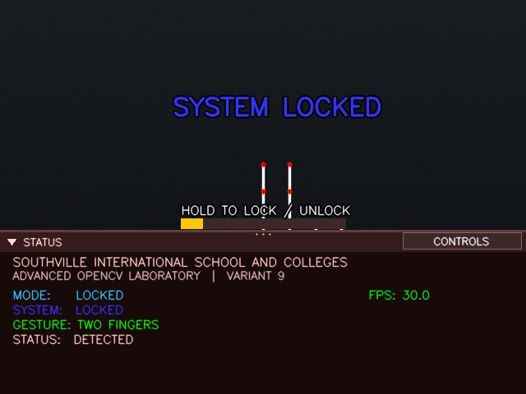
Figure 1. LOCKED mode: only the two-finger unlock gesture is recognised.

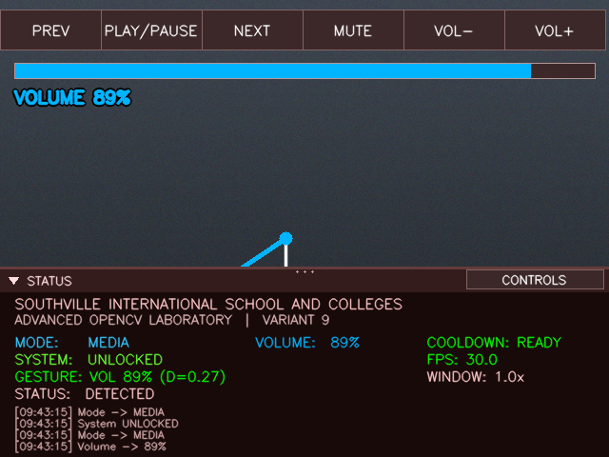
Figure 2. MEDIA mode: media buttons, volume bar, and the thumb-index line while the volume gesture is active.

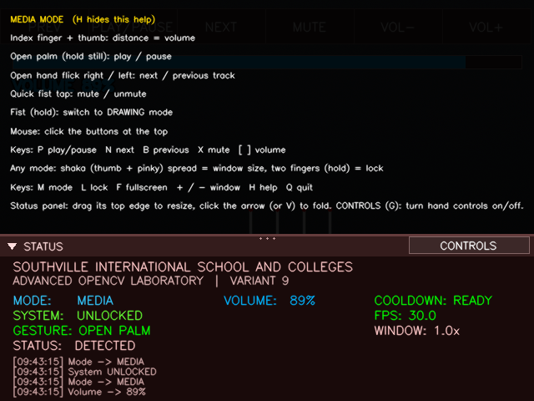
Figure 3. MEDIA mode help overlay listing only media controls.

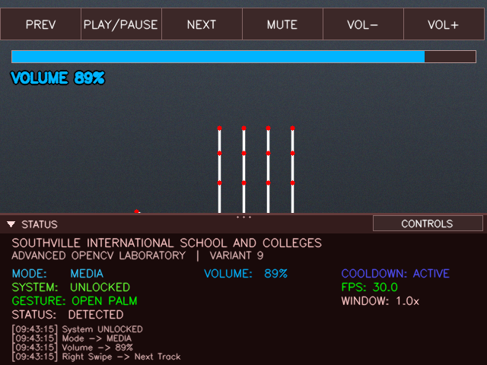
Figure 4. An open hand flick right is logged as "Right Swipe -> Next Track".

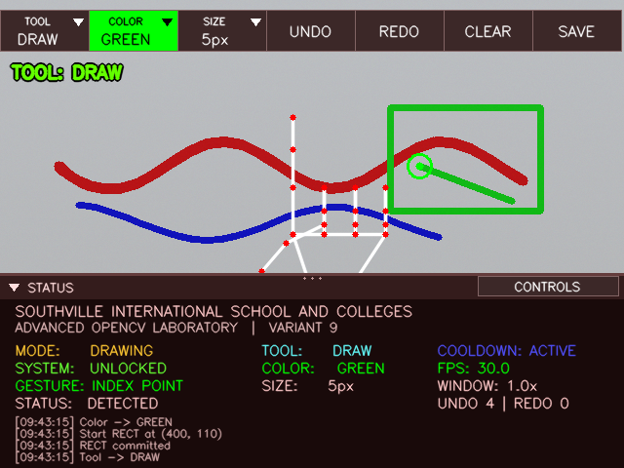
Figure 5. DRAWING mode with all bars closed; the header shows the current tool, color and size.

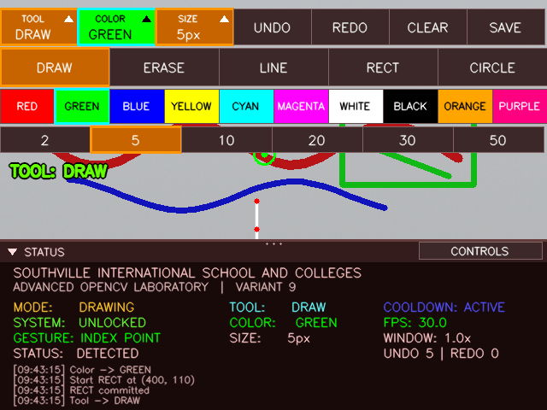
Figure 6. The tool, color and size bars opened from the header.

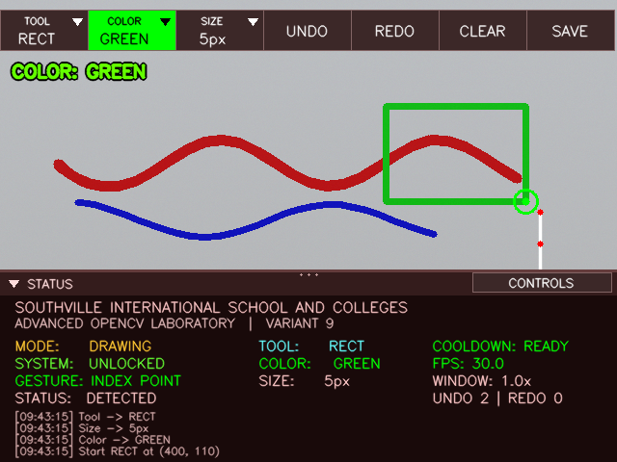

Figure 7. The rectangle tool previews the shape until a pinch commits it.

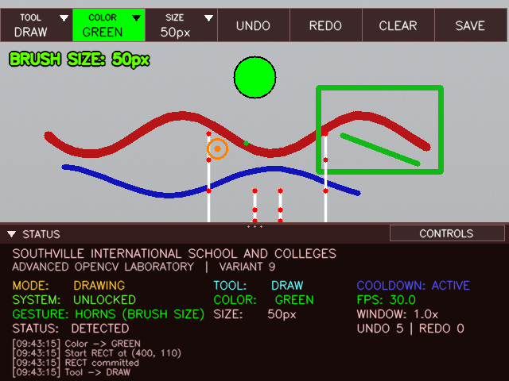
Figure 8. The horns gesture sets the brush size; the circle previews size and color.

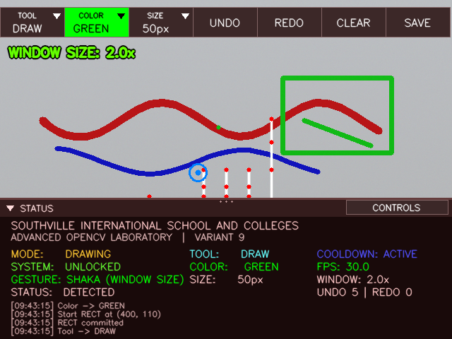
Figure 9. The shaka gesture sets the window size (message at the top left).

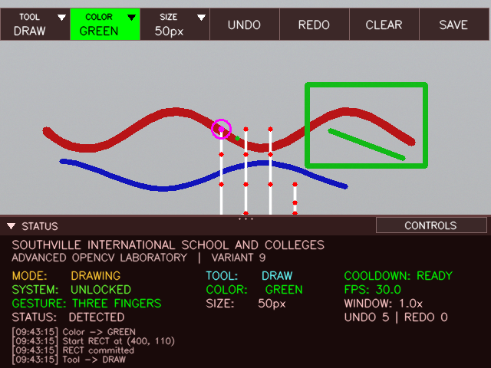
Figure 10. Three fingers are recognised; hold or flick left undoes, flick right redoes.

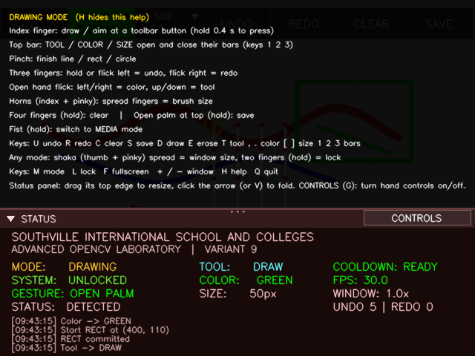
Figure 11. DRAWING mode help overlay.

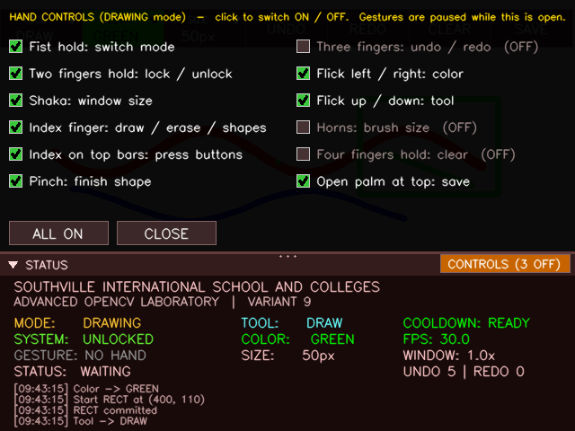
Figure 12. The CONTROLS button shows "3 OFF"; switched-off controls are greyed and marked.

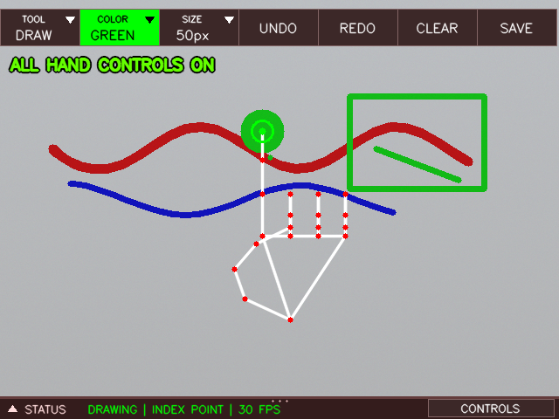
Figure 13. Folded status panel: one line with mode, gesture and FPS.

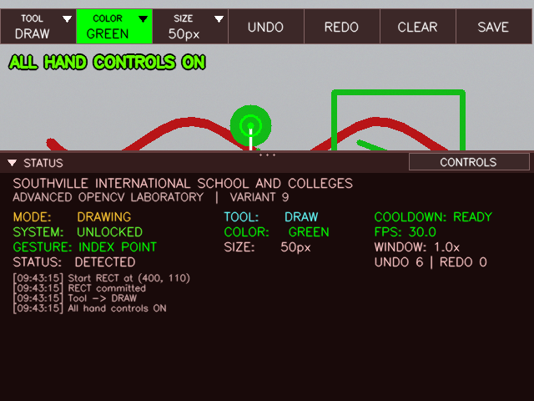
Figure 14. Taller status panel with all rows and the action log.

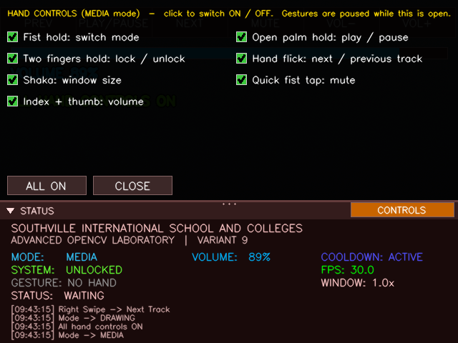
Figure 15. In MEDIA mode only media controls can be switched.

15. Surprise Modification: Implementation and Evidence

15.1 Record of the modification
Field | Entry
Statement of the surprise modification (copy it exactly) | [paste]
Date and time given | [fill in]
Gesture type involved | [static / motion / distance-based / multi-stage]
Mode affected | [MEDIA / DRAWING / both]
Files and functions changed | [fill in]
Constants changed (old value and new value) | [fill in]
Time taken | [fill in]

15.2 Implementation
[What I changed and why, step by step. Include the changed code lines.]

15.3 Evidence
Evidence | Where
Screenshot or video of the new behaviour | [insert]
Terminal log lines showing the action | [insert]
New test rows (S-style or H-style) with Expected and Actual results | [insert]
Regression check: the Pre-Lab gestures and the main drawing tools still work | [record]

15.4 Checklist for adding a new gesture or feature to this program
The program was built so that most modifications follow the same steps.
- Decide the gesture type (static, motion, distance-based, multi-stage) and the mode it belongs to.
- Add the pose or distance test among the gesture helpers and place it in _classify_gesture before any more general pose that it could be mistaken for.
- Add the gesture name to the right set in MODE_GESTURES.
- Add an entry to CONTROLS (and to GESTURE_CONTROL when the pose maps to one control) so it can be switched off.
- Write the handler. Use enabled(id), ready (cooldown), hand_still() for holds, dwell() for confirmation, and log with the right kind ("media" or "draw").
- Call the handler from _handle_media or _handle_drawing_mode.
- Add feedback: a toast, a progress bar, and a line in the help overlay; add a toolbar button or key if useful.
- Test it (a simulated row and a live row) and capture a screenshot.

Likely modification | Where to change it
Make a gesture easier or harder to trigger | Constants at the top: CONFIRMATION_TIME, SWIPE_THRESHOLD, STILL_THRESHOLD, the pinch distance in detect_pinching
Different volume range or sensitivity | MIN_DISTANCE, MAX_DISTANCE in volume_from_distance
Change brush range | MIN_BRUSH_SIZE, MAX_BRUSH_SIZE, BRUSH_RATIO_MIN, BRUSH_RATIO_MAX
Swap which pose does what | The branches in _handle_media and _handle_drawing_mode, and the order in _classify_gesture
Add a color | COLORS dictionary (BGR order); COLOR_ORDER follows automatically
Add a drawing tool | SHAPE_TOOLS, ShapeRenderer._draw, and the branch in _handle_drawing
Add a mode | MODES in StateManager, MODE_GESTURES, Toolbar.rows, a handler, and a branch in process_frame
Change the save location or file name | OUTPUT_DIR and _do_save
Change the cooldown | COOLDOWN_TIME

16. Reflection

16.1 False positives
Case | Cause | Mitigation | Remaining risk
Open palm mistaken for four fingers (or the reverse) | The thumb test compares x positions with the pinky base, so a rotated hand can fool it | Flicks treat both poses alike; only clear (four fingers) and save or play/pause (open palm) depend on the thumb | Wrong action if the thumb flickers between states
Pinch detected while drawing | Thumb close to the index tip while pointing | Pinch is only tested in DRAWING and only commits a shape | A stroke can stop when the thumb comes near the index
Quick fist passing through a gesture change | Many hand movements briefly look like a fist | Mute needs a 0.1 to 0.5 s fist and the cooldown; the mute control can be switched off | Accidental mute in MEDIA mode
Backswing of a flick | Returning the hand looks like a flick the other way | 0.7 s cooldown and clearing the movement history | A very slow backswing
Hold actions during movement | Clear, save or play/pause counted while the hand moved | Stillness check (under 35 px over 5 frames) | A hand drifting slowly
Toolbar pressed while moving the hand | The fingertip crosses the top bars on the way | 0.4 s hover with a progress bar; 0.5 s drawing guard afterwards | Resting the finger on the bars
Stray ink from cursor smoothing | The smoothed cursor lags the real fingertip, so it can still be in the canvas when the hand has moved to the toolbar | Drawing guard after a button press | Fast moves into the canvas
Other people or a second hand | Only hand 0 is used | Single-hand mode | The wrong hand may be tracked

16.2 Thresholds
Constant | Value | Reason | If it is too low | If it is too high
CONFIRMATION_TIME | 0.5 s | Long enough to be deliberate, short enough to be comfortable | Accidental lock, clear, mode switch | Feels slow
HOVER_CONFIRM_TIME | 0.4 s | Faster than the destructive holds because buttons are harmless to undo | Buttons press while passing over | Frustrating to select
COOLDOWN_TIME | 0.7 s | Stops one gesture firing repeatedly | Repeated actions | Cannot cycle colors quickly
SWIPE_THRESHOLD / _V | 80 / 60 px | About an eighth of the width and height of a 640 x 480 frame | Normal hand movement triggers flicks | Needs a very fast flick
STILL_THRESHOLD | 35 px | Normal hand tremor stays inside it | Holds almost never count | Holds count during slow movement
Pinch distance | 0.05 | Thumb and index tips almost touching | Pinch hard to make | Pinch triggers when pointing
MIN_DISTANCE / MAX_DISTANCE | 0.02 / 0.3 | Usable thumb-index range at arm's length | Volume jumps | Cannot reach 0 or 100 percent
SMOOTHING_FACTOR | 0.65 | Balance between jitter and lag | Jittery cursor | Laggy cursor
Detection / tracking confidence | 0.7 | Fewer wrong hands, still tracks reliably | More false detections | Hand lost more often
Horns and shaka ratios | 0.5 to 1.4 and 0.9 to 2.0 palm lengths | Estimated from typical hand proportions | Size or scale saturates early | Need an unnatural spread
The swipe, stillness and ratio values were chosen for a 640 x 480 image and a typical hand, and have not yet been tuned with a range of users. They are the first things to adjust.

16.3 State conflicts
Conflict | How it is resolved
One pose, different meaning per mode (index point is volume in MEDIA and drawing in DRAWING) | Mode-aware recognition and separate handlers
Fist: mute tap or mode switch | Duration decides: released between 0.1 and 0.5 s is mute; held 0.5 s switches mode and no mute follows
Open palm: play/pause, flick, or save | Flick is checked first; play/pause and save need a still hand and the cooldown; save also needs the top third of the image
Three fingers: undo hold, undo flick, redo flick | The flick is checked first; the hold needs a still hand
Shaka (global) against mode handlers | Shaka is handled before the mode branch, which is then skipped
Toolbar hover against drawing | A single list of rows defines the toolbar area for hit testing, drawing and the cursor test; 0.5 s guard after a press
Shape in progress when the mode changes or the system locks | The shape is cancelled
Gestures while the CONTROLS panel is open | All gesture actions are paused
Shared cooldown | One timer serves all actions, so an action of one kind can briefly delay another (a design trade-off for simplicity)
Switch off the lock gesture and get locked | Unlocking by gesture always works; the l key always works

16.4 Limitations
- Only one hand is tracked, and finger-extended tests assume an upright hand (they compare image y positions).
- The thumb test is a simple heuristic and is the weakest part of the recognition.
- Lighting, camera quality, occlusion and the distance to the camera all affect landmark quality.
- Pixel thresholds depend on the image size; timing depends on the frame rate.
- The canvas is the size of the camera frame; the history keeps 30 full snapshots in memory.
- The eraser has a fixed size.
- Window resizing depends on the OpenCV window backend; some Linux desktops ignore it.
- Media control depends on the tools installed, and on macOS on permissions.
- Hand-control switches, panel height and bar states are not saved between runs.
- The simulated tests in Section 21 check logic, not comfort; the live tests in 21.3 still have to be recorded.

16.5 Proposed improvements
Improvement | Benefit
Calibration step that measures the user's hand and sets the ratios and thresholds | Works for different hands and distances
Save settings (control switches, panel layout, thresholds) to a file | Remembers preferences
Rotation-independent finger test using joint angles instead of image y | Works with a tilted hand
Require a pose to be stable for several frames before it counts | Fewer false positives from transitions
Train a small classifier on recorded landmarks | More robust poses, including the thumb
Separate cooldowns per action family | Media and drawing actions no longer delay each other
Two-hand gestures such as pinch-zoom for the window | More natural resizing
Use landmark depth (z) | Brush pressure, or better distance estimates
Record and replay landmark sequences for automatic regression tests | Repeatable testing of every change
Filled shapes, text tool, color picker, canvas zoom, multi-hand support | Richer drawing

16.6 Lessons learned
The most important lesson was that most bugs came from interaction between features rather than from any single gesture: the same pose with two meanings, holds that counted while the hand moved, and interface elements that moved under the fingertip. The fixes that worked were structural: one mode-aware classifier, one list of toolbar rows used everywhere, a stillness check for every hold, and a single place (enabled()) to switch features off. Keeping the classifier free of side effects made the program easy to test with simulated landmarks, and the logging and on-screen feedback made problems visible quickly.

